Project Name

Jeppesen Task Order/s: [reference here]

HA/DR Test Plan

Document Version: 0.

Date:

|  |  |
| --- | --- |
| Business Area | Digital Aviation, High Availability / Disaster Recovery |
| Project Name |  |
| Phase |  |
| Test Plan Authors | [Jeppesen Test Focal], Jeppesen |
| Test Plan Version |  |
| Test Plan Finalization Date |  |
| Approval State | Baseline > Review > Revisions > Final |
| Confidential Category | Confidential |

Test Plan Approvals

|  |  |  |
| --- | --- | --- |
| Name | Role | Version Reviewed |
|  | Jeppesen, Project Manager |  |
|  | Jeppesen, Functional Analyst |  |
|  | Jeppesen, Test Manager |  |
|  | HA/DR Test Lead |  |
|  | DA SQA Specialist |  |
|  | Application Test Manager |  |
|  | Application Test Focal |  |
|  | Application Test Focal |  |
|  | Application Test Focal |  |
|  | System Integration Test Focal |  |
|  | Performance Test Focal |  |
|  | Company, Project Manager |  |
|  | Company, Test Manager |  |
|  | Company, Test Lead |  |
|  |  |  |
|  |  |  |

Document History

|  |  |  |  |
| --- | --- | --- | --- |
| Date | Version | Description of Changes | Author(s) |
|  | v0.1 | Initial draft |  |
|  |  | Baseline review |  |
|  |  | DA SQA review, revisions |  |
|  | v1.0 | Stakeholder review |  |
|  |  | Review revisions |  |
|  |  | Final approvals |  |
|  |  |  |  |
|  |  |  |  |

Project Stakeholders

|  |  |  |
| --- | --- | --- |
| Name | Role | Version Reviewed |
|  | Sr. Manager, Implementation |  |
|  | Project Manager |  |
|  | IPT Technology Portfolio Leader |  |
|  | HA/DR PM |  |
|  | HA/DR Test Lead |  |
|  | DA Software Quality Assurance Specialist |  |
|  | Application Test Manager |  |
|  | Application Test Focal |  |
|  | Application Test Focal |  |
|  | Application Test Focal |  |
|  | Application Test Focal |  |
|  | System Integration Test Focal |  |
|  | Performance Test Focal |  |
|  | Tier2 Lead |  |
|  | Application Solution Architect |  |
|  | [Company], Senior Manager |  |
|  | [Company], Delivery Manager |  |
|  | [Company], Test Manager |  |
|  | [Company], Test Lead |  |
|  | [Company], Tester |  |
|  | [Company], Tester |  |
|  | [Company], Tester |  |
|  | [Company], Tester |  |
|  |  |  |
|  |  |  |

Table of Contents

1. Introduction 1

1.1 Project Purpose 1

1.2 Document Purpose 1

1.3 Test Coverage 1

1.4 Testing Types 2

2. Application or Application Suite overview 2

3. In-Scope 3

3.1 High-level Test Scenarios 3

3.2 System Integration Sequence / Dependencies 3

4. Out-of-Scope 3

5. Data 3

5.1 Jeppesen Databases 3

5.2 Jeppesen Data Feeds 3

5.3 Application Login (database) 3

5.4 Manual Data Spreadsheets 4

6. Test / Co-located Environments 4

7. Test Approach 5

7.1 Functional Testing 5

7.2 Performance Testing…check the Task Order for wording 5

7.3 Issue Tracking 5

8. Test Execution Timeline 6

8.1 Test Schedule, Reporting 6

8.2 Test Execution – Application, System and Performance 6

8.3 Execution / Pass Rate – Application, System 6

9. Test Tools 6

10. Test Entry and Exit Criteria 7

10.1 Entry Criteria (conditions to start test execution) 7

10.2 Exit Criteria (conditions met before implementation) 7

11. Test Deliverables 7

12. Defect Management 8

12.1 Defect Severity Codes 8

12.2 Defect Priority Codes (Business Need) 8

13. Risks, Issues and Opportunities (RIOs) 9

14. Change Management 9

15. Appendix 9

15.1 Documents 9

15.2 Environment, Building 55 10

15.3 Acronyms 10

# Introduction

## Project Purpose

[Insert from Task Order]

## Document Purpose

This Test Plan addresses testing to verify this project’s application/s or suite of applications function as a whole, as determined by the project’s requirements and technical architecture.

In addition to functionality testing, this Test Plan also addresses the proper execution of application components with its interfacing systems (where applicable), and non-functional requirements.

Test readiness covers: what will be tested (in-scope), not tested (out-of-scope), the test schedule, and test deliverables. This includes supporting documentation, the test strategy, test timelines and milestones, infrastructure (test data and environments), test tools, roles and responsibilities, entry and exit criteria, test / defect / change management, assumptions, dependencies and constraints, links to test cases and test scenarios, as well as a Test Plan review. This Test Plan contains the detailed test strategy planned at the functional, system integration (SIT) and performance test levels.

## Test Coverage

This Test effort constitutes a validation of this project’s application/s in this project’s co-location environment, based on functional and/or system integration test cases contained in HP ALM or other Jeppesen test repositories. Performance test cases and results reside in HP Performance Center, unless otherwise indicated.

Jeppesen HP ALM Domain: FlightOps, Project: HADR_High_Avail_Disaster_Rec.

All test results and evidence will be documented in HP ALM Test Lab and reviewed by Jeppesen. An HA/DR Project folder is also located in Boeing’s instance of HP ALM.

* This Test Plan will be reviewed with project stakeholders then given to Jeppesen DA SQA as required for auditing purposes.
* Test Focals (internal and Company) will have coordinated meetings to review this Test Plan, which provides a forum for cross-functional engagement during the testing process. The project’s Test teams will continually monitor and track test progress based on the test schedule, as well as test reporting and metrics provided by the Company.
* A weekly metrics report will be compiled by the Company and shared with the Jeppesen Project Manager, Test Manager and Test Focals.
* A Test Evaluation Summary report following the conclusion of testing will be reviewed and signed-off by key stakeholders then given to Jeppesen DA SQA as required for auditing purposes.

## Testing Types

* Regression testing – executing test cases to validate that existing code is working as expected. Regression tests should be automated as much as possible.
* Functional testing – tests new features and functionality; can include negative and boundary test cases.
* Scenario testing – tests the product as customers would use the product.
* System or Integration testing – executing a suite of test cases to validate the interaction within and between applications, platforms and other interfaces work as expected.
* Performance testing – executing tests that measure the responsiveness and stability of the system, as well as to validate, investigate, and measure other quality attributes, such as scalability, reliability and resource usage.
* User Acceptance testing – a project team may decide to internally test functionally after regular testing has been completed
* Failover / Failback testing – failover is the process of shifting the I/O and its processes from the Primary Data Center (Bldg 55) to a co-location; this typically involves using a third-party tool that can temporarily halt the primary location’s I/O and restart it from a remote location. Failback is restoring operations from the secondary back to the primary data center.\

Test cases for system testing are captured in HP ALM and are initially manual test cases.

# Application or Application Suite overview

[Insert diagram here]

# In-Scope

## High-level Test Scenarios

[Jeppesen Test Focal inserts here]

## System Integration Sequence / Dependencies

The test strategy is to test the co-located environment in a bottom-up approach, i.e., test the back-end services by testing the client applications, in this order:

* [list in logical order, the applications under test]
* Failover / Failback testing

# Out-of-Scope

The following test items are out-of-scope:

* New functionality
* Client applications not listed in this Test Plan
* Any items not mentioned as in-scope within this Test Plan

# Data

## Jeppesen Databases

* [Jeppesen Test Focal lists here]

## Jeppesen Data Feeds

* [Jeppesen Test Focal lists here]

## Application Login (database)

* Test IDs and passwords > JAWS Account and Authentication

## Manual Data Spreadsheets

* A[Jeppesen Test Focal attaches to TC000 in their application’s HP ALM HA/DR project folder]

# Test / Co-located Environments

The systems/applications under test include:

|  |  |  |  |
| --- | --- | --- | --- |
| Environment | Intended Use | Data Profile | Availability |
| DR co-location (Tulsa or Seattle) | Regression, system, integration, security, performance testing | Obfuscated production data | 24/7, including support |
| Azure Sandbox | Regression, functional, system, integration, security, performance testing | Obfuscated production data | 24/7, including support |
| Azure | Regression, functional, system, integration, security, performance testing | Obfuscated production data | 24/7, including support |
| Bldg 55 – Silver and Gold | Sandbox and/or Failover / Failback testing | Obfuscated production data | 24/7, including support |

The Azure Sandbox test environment is a production-like environment where Building 55 production or refactored code is migrated and tested to validate functionality and application integration. Or a combination of Azure and Building 55 engines, applications or data may be needed in order to test.

Source to target data migration will be validated. Data will be synced from production 55 to the Azure environment (periodically or for each rehost project?)

|  |  |  |
| --- | --- | --- |
| Engine or Application | Description | Expected version in Prod at the time of Test |
|  |  |  |
|  |  |  |
|  |  |  |
|  |  |  |
|  |  |  |
|  |  |  |

# Test Approach

## Functional Testing

* Map individual test cases to project requirements in Jeppesen’s HP ALM
* Run smoke or regression application smoke test case suites in HP ALM
* Update or create new test cases as needed
* Ensure that system integration (at the application suite level) tests are included and updated as needed
* Run or add automated scripts using Jeppesen’s HP UFT 12, where applicable
* Run and document test case results in HP ALM
* Generate a Test Results Matrix report from HP ALM
* All test cases and results (screenshots) reside in HP ALM
* Update Issues / Ambiguity Tracker on a daily basis

## Performance Testing…check the Task Order for wording

Baseline performance testing will be done using production profiles with peak volumes for each transaction. The level of performance testing needed for a given project is determined by the Project Manager working with the Performance Test Focal:

* Capacity: load until servers fail (below, at, or above expectations)
* Endurance: memory leaks - capacity over a period of days
* Criterion: how many iterations of a business process defined by the client, ie, "an API call should make a round trip without failure within x seconds"
* Azure includes recovery, availability and scalability testing
* Create performance baselines where needed
* Develop a peak workload profile using production profiles
* Set up necessary monitoring
* Build a performance Test Plan and Design in HP Performance Center or similar tool

## Issue Tracking

* Any environmental, manual or automated test, or any anomalies that fail will be analyzed to determine root cause
* An Excel spreadsheet (Issue or Ambiguity Tracker) will be used to track and address issues raised during testing, and shared with the Jeppesen Test Focal
* A tracking tool should be used to track testing issues

Note: Issues are not necessarily defects. After communicating with the Jeppesen Test Focal, the Focal agrees that an issue is a defect before it is created

# Test Execution Timeline

## Test Schedule, Reporting

|  |  |  |
| --- | --- | --- |
| Activities | Planned Start Date | Planned End Date |
| Preconditions: |  |  |
| Co-location environment configurations |  |  |
| Application code migrations |  |  |
| Database, data feed setups, where applicable |  |  |
| Test: |  |  |
| Test Plan and stakeholder review |  |  |
| Application and SIT testing, with related artifacts |  |  |
| * weeks #-#: code migrations, data feeds, setups, preliminary testing |  |  |
| * week #: system integration testing, retest of issues |  |  |
| * week #: final testing (test suite end-to-end) |  |  |
| Performance testing, with related artifacts |  |  |
| Daily Issue Tracker |  |  |
| Weekly Metrics reporting |  |  |
| Test Evaluation Summary and stakeholder review |  |  |

## Test Execution – Application, System and Performance

|  |  |  |
| --- | --- | --- |
| Percentage Complete Milestone | Planned Start Date | Target Complete Date |
| 0% |  |  |
| 25% |  |  |
| 50% |  |  |
| 75% |  |  |
| 100% |  |  |

## Execution / Pass Rate – Application, System

|  |  |  |  |  |
| --- | --- | --- | --- | --- |
| Milestone | 25% | 50% | 75% | 100% |
| Execution |  |  |  |  |
| Pass Rate |  |  |  |  |

# Test Tools

|  |  |
| --- | --- |
| Tool |  |
| Excel Issue tracker | For observations or questions before defects are written |
| HP ALM, v12.2 | Test case suite repository, test execution tracking, defect management, reporting |
| HP Performance Center | Test, compare and validate application performance against baselines |
| JIRA | Defect tracking |
| Soap UI | API testing |
| Unix scripts | For engines or applications tested in line mode |
| Version One | Defect tracking |
|  |  |
|  |  |

# Test Entry and Exit Criteria

## Entry Criteria (conditions to start test execution)

* Task Order test elements incorporated into a completed Test Plan
* Functional and non-functional test cases or scripts, baselines, and data in readiness for testing
* Development completed (where applicable) and unit tested with results shared to Testing team
* Architecture and system dependencies provided
* Test Plan review with stakeholders, including revisions after the review meeting
* Functional and non-functional test execution tracking and communication between Test teams planned
* Functional and non-functional test results with screenshots, or other capture types, attached in a Test tracking tool
* Functional and Non-functional testing completed, with all quality criteria objectives met or otherwise explained
* Test or DR or Azure environment with engine/s, obfuscated Production-like data, and application/s installed, configured and ready to use state

## Exit Criteria (conditions met before implementation)

* 100% of functional, system integration and non-functional test cases and test scripts executed
* 100% of functional, system integration and non-functional test cases and test scripts Passed
* No open Urgent, Very High or High severity defects
* 95% of Medium severity defects have been closed
* All remaining defects are either closed or deferred
* Test Evaluation Summary review of test results and defects, with sign-off by key stakeholders

Entry and exit criteria are flexible benchmarks. If they are not met, the Test team will assess the risks, identify mitigation actions and provide a recommendation as input to the Project Manager for a final “go-no go” decision.

# Test Deliverables

|  |  |  |  |
| --- | --- | --- | --- |
| Document | Owner | Planned  Start Date | Planned Delivery |
| Test Plan, with stakeholder review | Jeppesen, Company |  |  |
| Initial test case suite in HP ALM | Jeppesen |  |  |
| Initial test data preparation / data spreadsheets | Jeppesen |  |  |
| New test cases written in HP ALM | Company |  |  |
| Issues tracker | Company > Jeppesen |  | Daily |
| Metrics reporting | Company > Jeppesen |  | Weekly |
| Test Evaluation Summary, with stakeholder review | Company > Jeppesen |  |  |

# Defect Management

* Defects are written for issues identified during testing, and are opened by the test team and assigned to the Jeppesen application Test Focal for evaluation and assignment to Development
* Development is responsible for updating the status of defects in a timely manner and updating defects to the “Fixed” status when it’s ready for re-test. Defects are not closed until they have been verified in the Test environment
* Blocking defects are marked as “Urgent”, which will be escalated to the development lead and Product Owner by the Jeppesen Test Focal
* To ensure each defect opened is valid, the test team will use the following verification steps:
  + test steps are executed correctly
  + data used is valid
  + databases/services in the Test environment are available
  + check log files if applicable
  + check documentation or contact the Jeppesen Test Focal to verify
  + duplicate the event in a different browser or on another computer
  + check to see if related to an existing defect
* If the defect is valid, create a defect using complete steps to duplicate the defect, with login and data information, including screen captures
* If defects start to accumulate or age, a defect triage meeting should be created

## Defect Severity Codes

|  |  |
| --- | --- |
| Description | Definition |
| Urgent | showstopper, cannot continue testing, requires immediate attention |
| Very High | difficult workaround with diminished capability |
| High | standard defect, neither a showstopper or a difficult workaround |
| Medium | affects minor functionality or non-critical data. It has an easy workaround |
| Low | The defect does not affect functionality or data and does not need a workaround; ie, spelling/grammatical errors. |

## Defect Priority Codes (Business Need)

|  |  |
| --- | --- |
| Description | Definition |
| High | must be fixed |
| Medium | may be fixed or deferred |
| Low | may or may not be fixed or deferred |

# Risks, Issues and Opportunities (RIOs)

|  |  |  |  |
| --- | --- | --- | --- |
| Risk Description | Risk Probability  (Low, Med, High) | Risk Impact  (Low, Med, High) | Risk Mitigation |
| Dependencies preceding applications are already in place in the new environment |  |  |  |
| Late delivery of the Test environment builds and configurations |  |  |  |
| Jeppesen Test Focals not available or inadequate test readiness (test cases, data, test IDs, knowledge transfer / demos, environmental or testing issue resolution not readily available) |  |  |  |
| [add additional as needed here] |  |  |  |
| [add additional as needed here] |  |  |  |
|  |  |  |  |
|  |  |  |  |

# Change Management

Please see Section 9 of the project’s Task Order

# Appendix

## Documents

|  |  |
| --- | --- |
| Document | Shared Location |
| Project Task Order | tbd |
| HA/DR Test Plan | tbd |
| Test scenarios | tbd |
| Test case suite | an HA/DR project folder in HP ALM |
| Manual test data spreadsheets | tbd |
| Performance test baselines | tbd |
| Test Traceability Matrix | tbd |
| Ambiguity / Issues Tracker | Tbd |
| Weekly test metrics | Tbd |
| Test Evaluation Summary | Tbd |

## Environment, Building 55

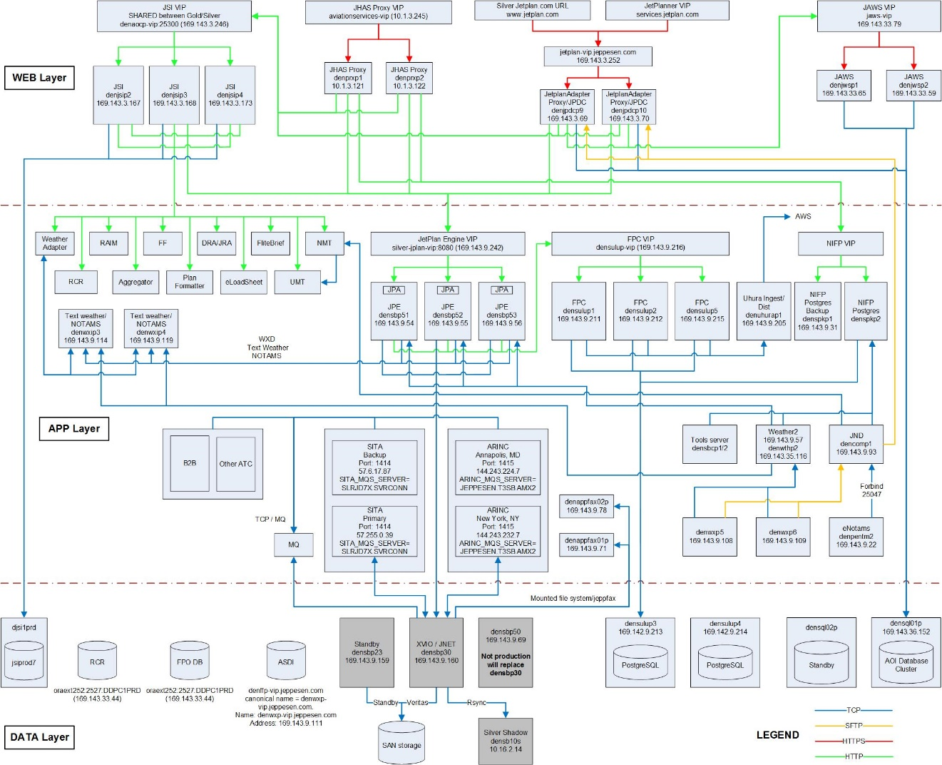

## Acronyms

| Acronyms | Description |
| --- | --- |
| CCB | Change Control Board |
| CM | Configuration Management |
| CR | Change Request |
| DAA | Digital Aviation Azure |
| HA | High Availability / Disaster Recovery |
| HP ALM | HP Application Lifecycle Management |
| HP UFT  UFT | HP Unified Functional Test |
| RTM | Requirements Traceability Matrix |
| TES | Test Evaluation Summary |
| TRR | Test Readiness Review (Test Plan) |
| [add application acronyms] |  |
|  |  |